**Non-Correlated Subquery:**

A non-correlated subquery is a subquery that can be executed independently of the outer query. The result of the subquery is calculated once and used to evaluate the outer query. Non-correlated subqueries typically execute once for the entire outer query.

**Example:**



In this example, the subquery **(SELECT AVG(Salary) FROM Employees)** calculates the average salary of all employees, and this result is used to filter employees with salaries greater than the average.

**Correlated Subquery:**

A correlated subquery is a subquery that depends on the outer query for its execution. For each row processed by the outer query, the subquery is executed, using values from the current row of the outer query. Correlated subqueries execute once for each row returned by the outer query.

**Example:**

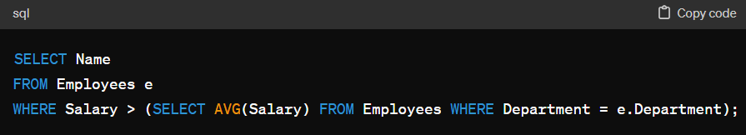

In this example, the subquery **(SELECT AVG(Salary) FROM Employees WHERE Department = e.Department)** calculates the average salary for each department. For each employee processed by the outer query, the subquery calculates the average salary for their department and compares it with their salary.

**Differences:**

* Non-correlated subqueries can be executed independently of the outer query, while correlated subqueries are dependent on the outer query.
* Correlated subqueries execute once for each row returned by the outer query, potentially leading to performance issues if not optimized properly.
* Non-correlated subqueries are often more efficient than correlated subqueries because they execute only once.

Understanding the distinction between correlated and non-correlated subqueries is essential for writing efficient SQL queries and optimizing database performance.